# Radiation Pattern of Phased Arrays

In this discussion, a LabVIEW simulation is provided to visualize the radiation pattern of the phased array antenna. The equations of the two-antenna array are first derived, followed by that for a generalized phased array antenna. The LabVIEW project to aid in visualization of this is then presented.

An antenna array is a group of similar antennas spaced and phased out regularly. The antenna array aims to improve the directivity and gain of the radiated beam. The dipole antenna was simple and radiated omnidirectionally. This resulted in reduced gain and directivity. With the antenna array, the individual contributions of each dipole antenna in the array add up such as to produce the desired radiation pattern.

## Two-Antenna Array

Consider the interaction of the radiations from two dipole antennas separated by distance d at a point P.

P

r2

r

r1

d

The path length r1 from one of the antennas is longer than the other path length r2. Assuming point P is in the far field (a long distance away from the radiating elements), the two paths r1 and r2 can be considered to be parallel as shown.

r2

r1

d

Considering the right-angle triangle formed, it is seen that the path difference between r1 and r2 is . The phase difference between the two paths is then this path length difference multiplied by the wave number:

$$ѱ=k∙d∙cosθ$$ Including an intentional phase difference $δ$, the phase difference is:

$$ѱ=k∙d∙cosθ$$

Arbitrarily assigning one of the signals to have a phase angle of $+\frac{ѱ}{2}$ and the other $-\frac{ѱ}{2}$, the sum of the electric fields from the antennas can be written as:

$$E\left(r\right)=E1(r)(e^{\frac{jѱ}{2}}+e^{-\frac{jѱ}{2}})$$

Factoring 2 out:

$$E\left(r\right)=2E1\left(r\right)\left(\frac{{(e}^{\frac{jѱ}{2}}+e^{-\frac{jѱ}{2}})}{2}\right)$$

$$E\left(r\right)=2E1\left(r\right)∙\cos\left(\frac{ѱ}{2}\right)$$

$$E\left(r\right)=2E1\left(r\right)∙\cos\left(\frac{k∙d∙cosθ}{2}\right)$$

Notice that the electrical field of one antenna (E1 in this case) has been multiplied by a factor to give the resultant electric field. This is known as the **pattern multiplication rule**. The rule states that the radiation pattern of an antenna array is the product of the radiation pattern of one antenna $F1\left(θ,Φ\right)$ multiplied by the element factor $Fa\left(θ,Φ\right)$:

$$F\left(θ,Φ\right)=F1\left(θ,Φ\right)∙Fa\left(θ,Φ\right)$$

In the case of a two antenna array, the element factor is:

$$Fa\left(θ,Φ\right)=2\cos\left(\frac{k∙d∙cosθ}{2}\right)$$

Which on normalizing gives:

$$Fa\left(θ,Φ\right)=\cos\left(\frac{k∙d∙cosθ}{2}\right)$$

## Phased Array

A phased array is a group of antennas separated and phased regularly. This is essentially an extension of the two antenna array with more elements. Similar to the discussion of the two-element array, consider the interaction of the multiple antennas at a point P. Considering the paths from a far source, the paths can be visualized as shown:

$$dcosθ$$

$$dcosθ$$

d

$$θ$$

d

$$θ$$

$$dcosθ$$

d

$$θ$$

$$dcosθ$$

d

$$θ$$

The same technique discussed for the phase difference of the two-element array can be extended in this case. The phase difference adds up with each antenna. Assuming that each antenna has an element factor of $E1\left(θ,Φ\right)$, the total electric field can be written as:

$$E\left(r\right)=E1(r)({1+e}^{jѱ}+e^{2jѱ}+e^{3jѱ}+e^{4jѱ})$$

Generalizing this to N elements:

$$E\left(r\right)=E1(r)({1+e}^{jѱ}+e^{2jѱ}+∙∙∙+e^{j(N-1)ѱ})$$

Which can be re-written as a geometric series:

$$E\left(r\right)=E1\left(r\right)\left[\frac{{1-e}^{jNѱ}}{{1-e}^{jѱ}}\right]$$

Considering only the magnitude of the electric field, the equation becomes:

$$E\left(r\right)=E1\left(r\right)\left(\frac{sin\frac{\left(Nѱ\right)}{2}}{sin\frac{\left(ѱ\right)}{2}}\right)$$

The element factor in this case is:

$$F\left(θ,Φ\right)=\frac{sin\frac{\left(Nѱ\right)}{2}}{sin\frac{\left(ѱ\right)}{2}}$$

## LabVIEW Visualization of the Phase Array Radiation Pattern

We have derived the magnitude of the electric field for a phased array to be:

$$E\left(r\right)=E1\left(r\right)\left(\frac{sin\frac{\left(Nѱ\right)}{2}}{sin\frac{\left(ѱ\right)}{2}}\right)$$

LabVIEW can be used to visualize the radiation pattern of the phased array. Through LabVIEW, different number of elements, phase angles, and distances between the radiating elements can be interactively modified and the resultant radiation pattern observed.

The block diagram that implements the phased array equation is as shown:

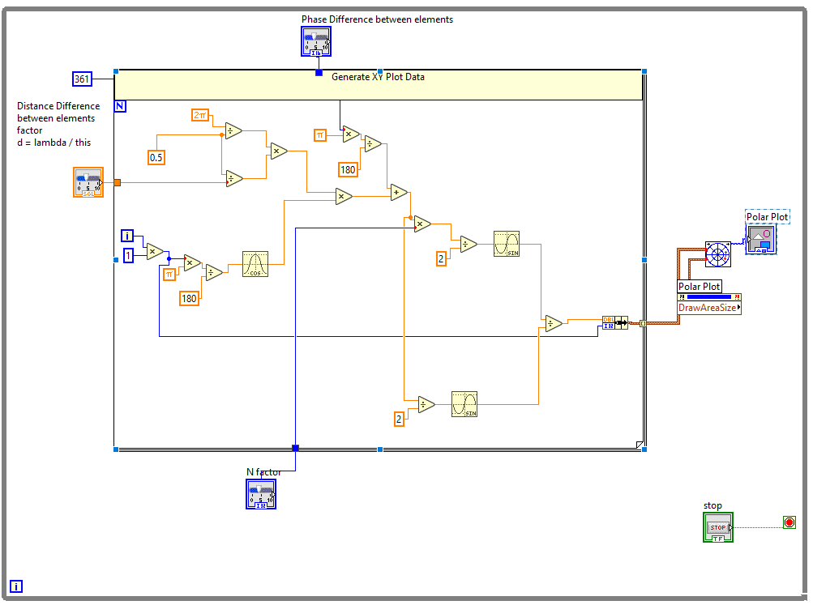

The front panel of the project is as shown. Here, the N factor, phase angle, and the distance separating elements (d) can be set by using a slider.

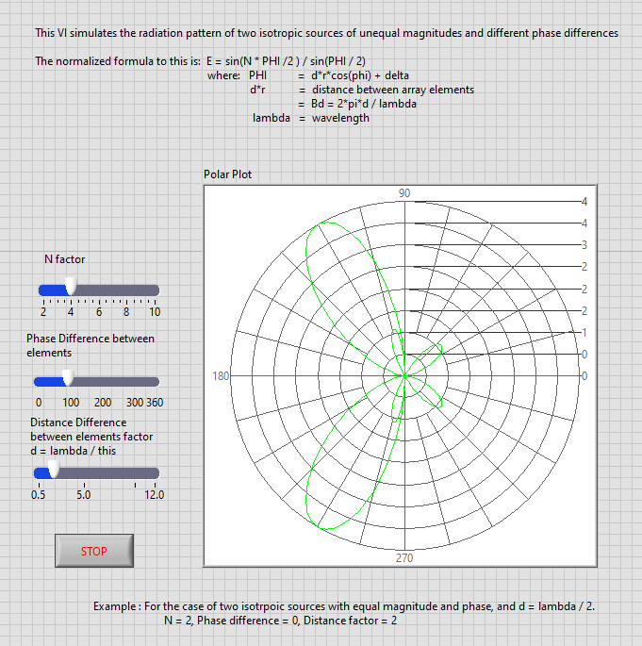

Some radiation patterns observed are as follow: